SREE RAMA ENGINEERING COLLEGE

### RAMIREDDY NAGAR, TIRUPATHI-517501.



COMMUNITY SERVICE PROJECT REPORT

### On

### GROUND WATER PROBLEMS CAUSED BY SEWAGE WATER EFFULUENT

### By

P.KARTHIK

### (204C1A04B2)

Department of ELECTRONICS & COMMUNICATION ENGINEERING

### (2020-2024)

Under the guidance of Mrs.M.RAJESWARI

### Department of ECE

**Program Book for Community Service Project**

**Name of the Student :** P.Karthik

**Name of the College :** Sree Rama Engineering College

**Registration Number :** 204C1A04B2

**Period of CSP :** III – I Semester

**Name & Address of the Community/Habitation:** Anasampalli,Tirupati

#### Instructions to Students for Community Service Project

**Please read the detailed Guidelines on Community Service Project hosted on the website of AP State Council of Higher Education** [**https://apsche.ap.gov.in**](https://apsche.ap.gov.in/)

**Link:** [**https://apsche.ap.gov.in/Pdf/Guidelines%20for%20the%20OJT%20Internship**](https://apsche.ap.gov.in/Pdf/Guidelines%20for%20the%20OJT%20Internship%20Community%20Service%20Project.pdf)

[**%20Community%20Service%20Project.pdf**](https://apsche.ap.gov.in/Pdf/Guidelines%20for%20the%20OJT%20Internship%20Community%20Service%20Project.pdf)

1. It is mandatory for all the students to complete 2 months (180 hours) of Community Service Project as a part of the 10 month mandatory internship/on the job training.
2. Consider yourself as a committed volunteer in the community, you work with.
3. Every student should identify the village/community/habitation for Community Service Project (CSP) in consultation with the College Principal/the authorized person nominated by the Principal.
4. Report to the community/habitation as per the schedule given by the College. You must make your own arrangements of transportation to reach the community/habitation.
5. You will be assigned with a Faculty Guide from your College. He/She will be creating a WhatsApp group with your fellow volunteers. Post your daily activity done and/or any difficulty you encounter during the programme.
6. You should maintain punctuality in attending the CSP. Daily attendance is compulsory.
7. You are expected to learn about the community/habitation and their problems.
8. Know the leaders and the officials of the community/habitation.
9. While in project, always wear your College Identity Card.
10. If your College has a prescribed dress as uniform, wear the uniform daily.
11. Identify at least five learning objectives in consultation with your Faculty Guide. These learning objectives can address:
    * Information about the community, including the realities and problems of the society.
    * Need for creating awareness on socially relevant aspects/programs.
    * Acquiring specific Life Skills.
    * Learning areas of application of knowledge and technologies related to your discipline.
    * Identifying developmental needs of the community/habitation.
12. Practice professional communication skills with team members, and with the leaders and officials of the community. This includes expressing thoughts and ideas effectively through oral, written, and non-verbal communication, and utilizing listening skills.

#### Be regular in filling up your Program Book. It shall be filled up in your own handwriting. Add additional sheets wherever necessary.

1. At the end of Community Service Project, you shall be evaluated by the person in- charge of the community/habitation to whom you report to.
2. There shall also be evaluation at the end of the community service by the Faculty Guide and the Principal.
3. Do not indulge in any political activities.
4. Ensure that you do not cause any disturbance to the inhabitants or households during your interaction or collection of data.
5. Be cordial but not too intimate with the persons you come across during your service activities.
6. You should understand that during this activity, you are the ambassador of your College, and your behavior during the community service programme is of utmost importance.
7. If you are involved in any discipline related issues, you will be withdrawn from the programme immediately and disciplinary action shall be initiated.
8. Do not forget to keep up your family pride and prestige of your College.
9. Remember that you are rendering valuable service to the society and your role in the community development will become part of the history of the community.

# Community Service Project Report

*Submitted in accordance with the requirement for the degree of* Name of the College : Sree Rama Engineering College Department : Electronics & Communication Engineering

### Name of the Faculty Guide : Mrs.M.Rajeswari

Duration of the CSP : III – I Semester

### Name of the Student : P.Karthik

### Programme to Study : Bachelor of Technology

### Year of Study : III year

### Register Number : 204C1A04B2

### Date of Submission : 18-01-2023

# Student’s Declaration

I, **P.Karthik,** a student of **Bachelor of Technology** Program, Reg. No **204C1A04B2** of the Department of **Electronics & Communication Engineering, Sree Rama Engineering College** College do hereby declare that I have completed the mandatory community service project in III – I semester at **Anasampalli, Tirupati,** under the Faculty Guideship of **Mrs.M.Rajeswari**,Department of **Electronics and Communication Engineering** in **Sree Rama Engineering** College.

(Signature and Date)

# Endorsements

Faculty Guide

Head of the Department

Principal

**Certificate from Official of the Community**

This is to certify that **P.Karthik ,** Reg. No **204C1A04B2** of **Sree Rama Engineering College** underwent community service at **Anasampalli, Tirupati**, in III – I semester. The overall performance of the Community Service Volunteer during his/her community service is found to be **Good**.

Authorized Signatory with Date and Seal

## ACKNOWLEDGEMENT

The satisfaction that accomplishes the successful completion of the task would be put incomplete without the mention of the people who made it possible, whose constraint guidance and encouragements crown all the efforts with success.

We avail this opportunity to express our deep sense of gratitude and heartily thanks to

**Mr. M. RAMI REDDY,**, Hon’ble Secretary of SRET-Tirupati, for providing congenial atmosphere and encouragement.

We would like to express our heartful thanks to Mr.**Dr. Jaya chandra,** Principal, for successful completion of this project report, which cannot be done without proper support and encouragement.

We would like to express our gratefulness and sincere thanks to **Ms. Dr. M. Hemalatha,**(Ph.D) HOD, Department of ECE, for his kind help and encouragement during the course of study and in the successful completion of the project report.

We are thankful to our guide **Mrs.M.Rajeswari**, Department of ECE for his valuable guidance and encouragement. His helping attitude and suggestions have helped in the successful completion of the project report.

We especially Thankful to **Andhra Pradesh State Council of Higher Education** for giving this opportunity to Service the community and adding this kind of Project into our curriculum which is more helpful to us to know about the society.

We sincerely thankful to Management for providing all the necessary facilities during course of study.

We would like to express our deep gratitude to all those who helped directly or indirectly to transform an idea into our working project report.

#### CHAPTER 1: EXECUTIVE SUMMARY

Sewage effluent water is consistently used for the agricultural irrigation in rural and urban region farms. The spread of the potential infectious diseases is the major concern for farm workers and also for city inhabitant when they get exposed to these effluents. The activities we performed in the community service are giving awareness to farmers regarding how the sewage effuluents effecting in various ways. How to protect them from diseases arised and a better growth in ground water levels.

#### Objectives:

* They also will affect those people consuming crops developed using effluent water irrigation system, particularly when the farm produce is consumed raw by people or otherwise, the farm yield is brought in that raw condition into the kitchen.
* Commercialization of hi‐tech cultivation in the state.
* Expansion of commercial for sustainable crop production.
* Only way of preventing is by making adequate measures to disinfect the effluent
* Best utilization of wastes.
* To introduce new commercial varieties to enhance the crop production.
* To practice farming in a profitable way.
* To improve the economic condition of the rural farmers.
* Production of quality planting materials of crops in the locality to cater the need of the farmers.

#### Outcomes:

* + - Only way of preventing is by making adequate measures to disinfect the effluent
    - As we the society also learned a lot more things from them how to increase the growth of plants of flora

**CHAPTER 2: OVERVIEW OF THE COMMUNITY**

WATER is a key input to the agricultural production and therefore fluctuations in water availability may impact agricultural productivity and revenue.

HOW DOES RAINFALL AFFECT AGRICULTURE?

rain is usually seen as benefit to crops and fields. but there is an “ideal” amount of any rainfall in any given growing season for most crops. If the average rainfall is much lower or higher than ideal. it can lead to significant problems, from drowned crops to lower yields.

Our community service project is regarding awareness to the people on cultivation in the society and we also had surveys in the fields near by Tirupati.We also got permission from the sarpanch for doing this survey.

After our survey which is conducted in phase – I, we had conducted some awareness on cultivation importance in the society .The importance of cultivation is understood by the people and started using the effective techniques for growth of floral plants

**CHAPTER 3 COMMUNITY SERVICE PART**

Water, Water Governance

March, 2022

The water flowing beneath the surface is the largest source of fresh water on the planet. This “hidden resource” accounts for just [0.62% of the total water](https://www.usbr.gov/mp/arwec/water-facts-ww-water-sup.html) and [30% of the freshwater available on earth](https://www.un-igrac.org/what-groundwater#:~:text=Groundwater%20represents%20about%2030%25%20of%20world's%20fresh%20water.).

It is also India’s most used water resource. Home to over a billion people, the pressure on subsurface water in the country is immense, accounting for a quarter of total groundwater extraction in the world. [Groundwater extraction in India is more than the combined extraction in China and the US](https://www.thehindu.com/news/cities/mumbai/the-alarming-levels-of-indias-groundwater/article19253949.ece).

Furthermore, groundwater recharge has been adversely affected on account of disruptions in the hydrological cycle due to climate shifts. All of this translates into [more than a third of India’s population living in water-stressed areas](https://graphics.reuters.com/INDIA-ENVIRONMENT-WATER/0100B2C41FD/index.html), a number set to increase with intensifying climate impacts and accelerated urbanisation.

Water availability, or the lack of it, is a cross-cutting issue. Given the interlinkages between water, environment and socio-economic well-being, the challenges in groundwater resource management are complex and multifold. Some of these include:

Groundwater, regarded as a “common pool resource”, has historically witnessed little control over its extraction. Driven by a rising population, urbanisation and expansion of irrigation activities, groundwater extraction has been on the rise for several decades.

**WEEK–I Report**

(From Date03-09-2022 to Date08-09-2022)

**Objective of the Activity Done:** Conducted survey programs concerning about water problems

**Detailed Report**: conducted survey on the ground water problems in their natives

* Found that some sewage from the surroundings effecting the ground water.
* Sewage effuluents causing mild damage.
* Discussed about chronological diseases there around the village.
* Survey done regarding the problems according to water scarcity.
* No water scarcity found in the village.
* Survey done in the village for finding some

**Unregulated extraction**

Groundwater, regarded as a “common pool resource”, has historically witnessed little control over its extraction. Driven by a rising population, urbanisation and expansion of irrigation activities, groundwater extraction has been on the rise for several decades.

Triggered by the Green Revolution, groundwater use has exploded in India since the 1970s. Availability of cheap electricity shifted farmers’ dependency from surface water to groundwater. [For instance, of the total irrigated area in Punjab, only 26.2% is irrigated by surface water](https://timesofindia.indiatimes.com/blogs/economic-policy/did-green-revolution-in-punjab-lead-to-groundwater-over-exploitation-revolution-due-to-msp/). This, despite five rivers flowing through the state.

**WEEK – II Report**

(From Dt 10-09-2022 to Dt 15-09-2022 )

**Objective of the Activity Done:** Conducted awareness programs concerning about the ground water and its problems due to scarcity.

#### Detailed Report:

As a part of second phase of our community service project we again took permission from the head sarpanch and he allowed us to give some advices to the cultivators of crops. Always use appropriate quantity of pollutant based on soil test.

**Excessive irrigation**

Irrigation alone accounts for [90% of the total groundwater used in India today](https://link.springer.com/article/10.1007/s13201-021-01543-%20w#:~:text=India's%20groundwater%20consumption%20dramatically%20increased,and%202010%20(MoSPI%202015).). Groundwater irrigation popularised in the 1970s has led to socio-economic well-being, increased productivity and better livelihoods.

However, it may not be sustainable in the long term. Even with climate-friendly choices (such as solar-powered pumps), there is a minimal direct effect on groundwater levels which are hitting a low at a rapid rate.

Conservation and management of soil and water are central to groundwater recharging. But with the lack of a “comprehensive and integrated land use planning” framework, [effects are seen in declining water tables](https://smartnet.niua.org/sites/default/files/resources/draft_national_land_utilisation_policy_july_2013.pdf).

A cursory understanding of the effects of changes in the terrestrial biosphere makes matters worse. For example, while land-use changes such as converting rangelands into agricultural ecosystems may increase groundwater recharge,[it comes at the expense of groundwater quality](https://pubs.er.usgs.gov/publication/70027836). There is thus a need for better agriculture planning and land use management. This would be crucial to improving both groundwater quantity and quality.

**WEEK–III Report**

(From Date 17-09-2022 to Date 22-09-2022)

**Objective of the Activity Done:** Conducted survey programs concerning about sewage water nad how it damages the ground water pollutant level.

#### Detailed Report:

The health hazards posed by inorganic fertilizers, pesticides and herbicides cannot be over looked. Despite this, there is still the need to know empirically the level of awareness and use of organic farming practices and socio-economic factors influencing it among horticultural farmers.

Data for the study were collected through qualitative and quantitative methods involving Focus Group Discussion (FGD) as well as the use of structured interview schedule. A total number of 200 respondents were sampled and they were selected through multi-stage and purposive sampling techniques from the four villages of one district.

Data were analyzed inferential statistics such as frequency counts, percentages etc. Half of the respondents falls between the ages brackets of 30-40 years (50 %). 46.8 % of the respondents have a household size of 4-6, while 60 % are females and 40 % males. Awareness score of 85.5 % of the respondents about organic farming was high while 61.3 % were into organic farming though unconsciously.

Most (96.8 %) of the respondents identified time consuming as the highest constraints in organic farming practices. percentage analysis revealed that, land acquisition, educational qualification and source of information have significant influence on horticultural farmers awareness and use of organic farming practices.

It was therefore recommended that, female farmers should be encouraged and empowered in organic farming practices. Capacity building through training of respondents on newly generated technologies in organic farming practices should be embarked upon to improve the health and livelihood of farmers. Keywords: Organic farming practices, awareness and use, horticultural farmers, socio- economic factors, empowerment and livelihood.

**WEEK–IV Report**

(From Date 24-09-2022 to Date 29-09-2022)

**Objective of the Activity Done:** Conducted survey programs concerning about the problems arised due to sewage effuluents.

#### Detailed Report:

**Organic Farming Advantages:**

**Poor knowledge of groundwater management systems**

The mismatch in demand and supply at the local level represents a large part of the problem in India. The reasons behind this are multifaceted and may be less direct than say, a rising population or rampant urban development. For example, better economic status of a population may assert more demand for water supply and distribution.

Other complications stem from [a shift to individual “access” as opposed to a community model](https://dlc.dlib.indiana.edu/dlc/bitstream/handle/10535/7340/397.pdf?sequence=1). A lack of clarity on the aquifer boundaries further makes it difficult to formulate clear guidelines for proper management of groundwater systems. Finally, as hydrologic conditions vary intricately yet considerably at the local level, centralised approaches remain limited in their reach and impact. This unequivocally transfers the responsibility to local regulatory bodies at the block level, the Panchayat and Municipality, which are well-placed to address these issues.

However, studies reveal that, [the role of Panchayats in groundwater management has been negligible, or at best, casual](http://cgwb.gov.in/INCGW/Kamta%20Prasad%20report.pdf). Even with communities empowered with governance rights and awareness, [success was limited due to weak local institutions](https://ieg.worldbankgroup.org/blog/addressing-groundwater-depletion-lessons-india-worlds-largest-user-groundwater). This is primarily due to the technical incompetence and insufficient finances that affect the local bodies’ ability to address local level heterogeneity in groundwater management. Addressing this would help strengthen and scale-up pilot projects at the local level. Supported by impact assessments, such interventions would pave the way for [informed, refined, and robust policy-making based on on-ground developments](https://www.sciencedirect.com/science/article/pii/S2214581814000469)

**WEEK–V Report**

(From Date 31-09-2022 to Date 05-10-2022)

**Objective of the Activity Done:** Conducted survey programs concerning about protecting ground water levels for children in the local scholls for awareness.

**Detailed Report:**

**Climate change**

The cumulative effect of all the challenges mentioned above is intensified by the climate shocks experienced by the country. The problems groundwater faces in India feeds into worsening the climate crisis, which further deepens the distress associated with groundwater availability. Disturbances in the hydrological cycle causing long spells of floods and droughts adversely affect the quality and quantity of groundwater. For example, flood events risk increased runoff of chemicals and biotic contaminants into groundwater.

[Long period of droughts can lead to aquifer depletion, which may take 3 years to recover](https://www.sciencedirect.com/science/article/abs/pii/S0022169421009677). However, in case of excessive pumping in such areas, recovery may take longer. [Additionally, heavy subsidies on irrigation pumps and access to cheap electricity contribute substantially to the overall emissions from the agriculture sector](https://unfccc.int/sites/default/files/resource/INDIA_%20BUR-3_20.02.2021_High.pdf), which is the second-most emitting sector in the country. Despite schemes and subsidies for the adoption of solar pumps, diesel-based irrigation pumps account for 8.8 million units. [This is excluding the 20.3 million units that are connected to a primarily fossil-fuel driven electricity grid](https://www.iea.org/data-and-statistics/charts/estimated-stock-of-agricultural-irrigation-pumps-in-india-2010-2022). This only exacerbates the climate vulnerabilities India faces now and in the future.

[Read about WOTR’s sustainable interventions in soil and water conservation in Odisha that are offering climate resilience to the communities.](https://wotr.org/2021/05/27/soil-and-water-conservation-sustainable-pathways-for-climate-resilience-through-agriculture-intensification/)

In essence, critical issues surrounding heterogeneity in groundwater conditions need overarching solutions while keeping the Indian socio-economic context in view. Informed policy-making based on comprehensive understanding supplemented with an integrated approach where every entity takes responsibility for groundwater management would prepare the groundwork for a water-secure future.

#### CHAPTER 4

The water flowing beneath the surface is the largest source of fresh water on the planet. This “hidden resource” accounts for just 0.62% of the total water and 30% of the freshwater available on earth.

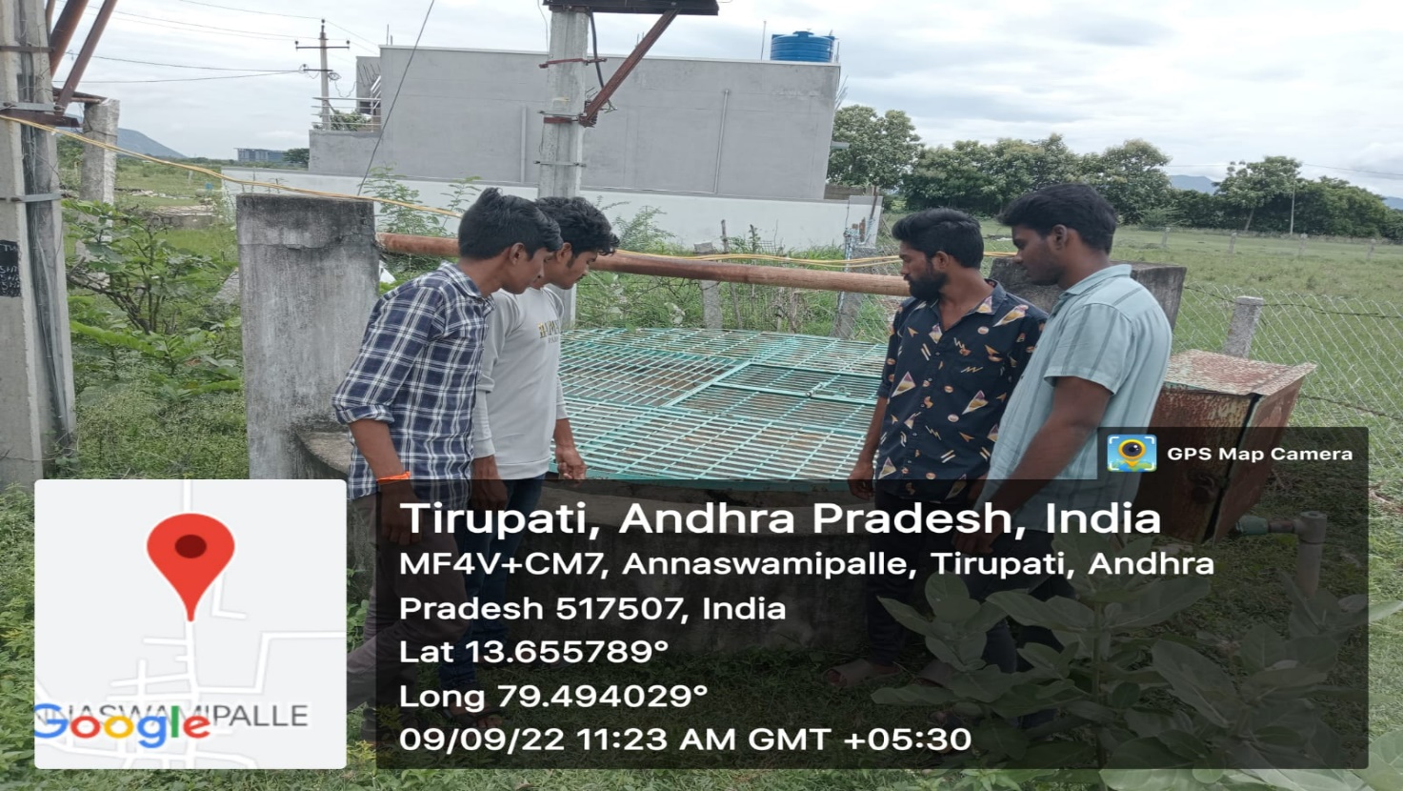

It is also India’s most used water resource. Home to over a billion people, the pressure on subsurface water in the country is immense, accounting for a quarter of total groundwater extraction in the world. [Groundwater extraction in India is more than the combined extraction in China and the US](https://www.thehindu.com/news/cities/mumbai/the-alarming-levels-of-indias-groundwater/article19253949.ece).

Furthermore, groundwater recharge has been adversely affected on account of disruptions in the hydrological cycle due to climate shifts. All of this translates into [more than a third of India’s population living in water-stressed areas](https://graphics.reuters.com/INDIA-ENVIRONMENT-WATER/0100B2C41FD/index.html), a number set to increase with intensifying climate impacts and accelerated urbanisation.

**COMMUNITY SERVICE PROJECT IDEAS**

You CAN make a difference in your town by educating people about the water they drink every day! Here are some ideas for projects that kids and adults can do in their hometown. The ideas listed here are just to start you thinking; you are encouraged to develop your own!

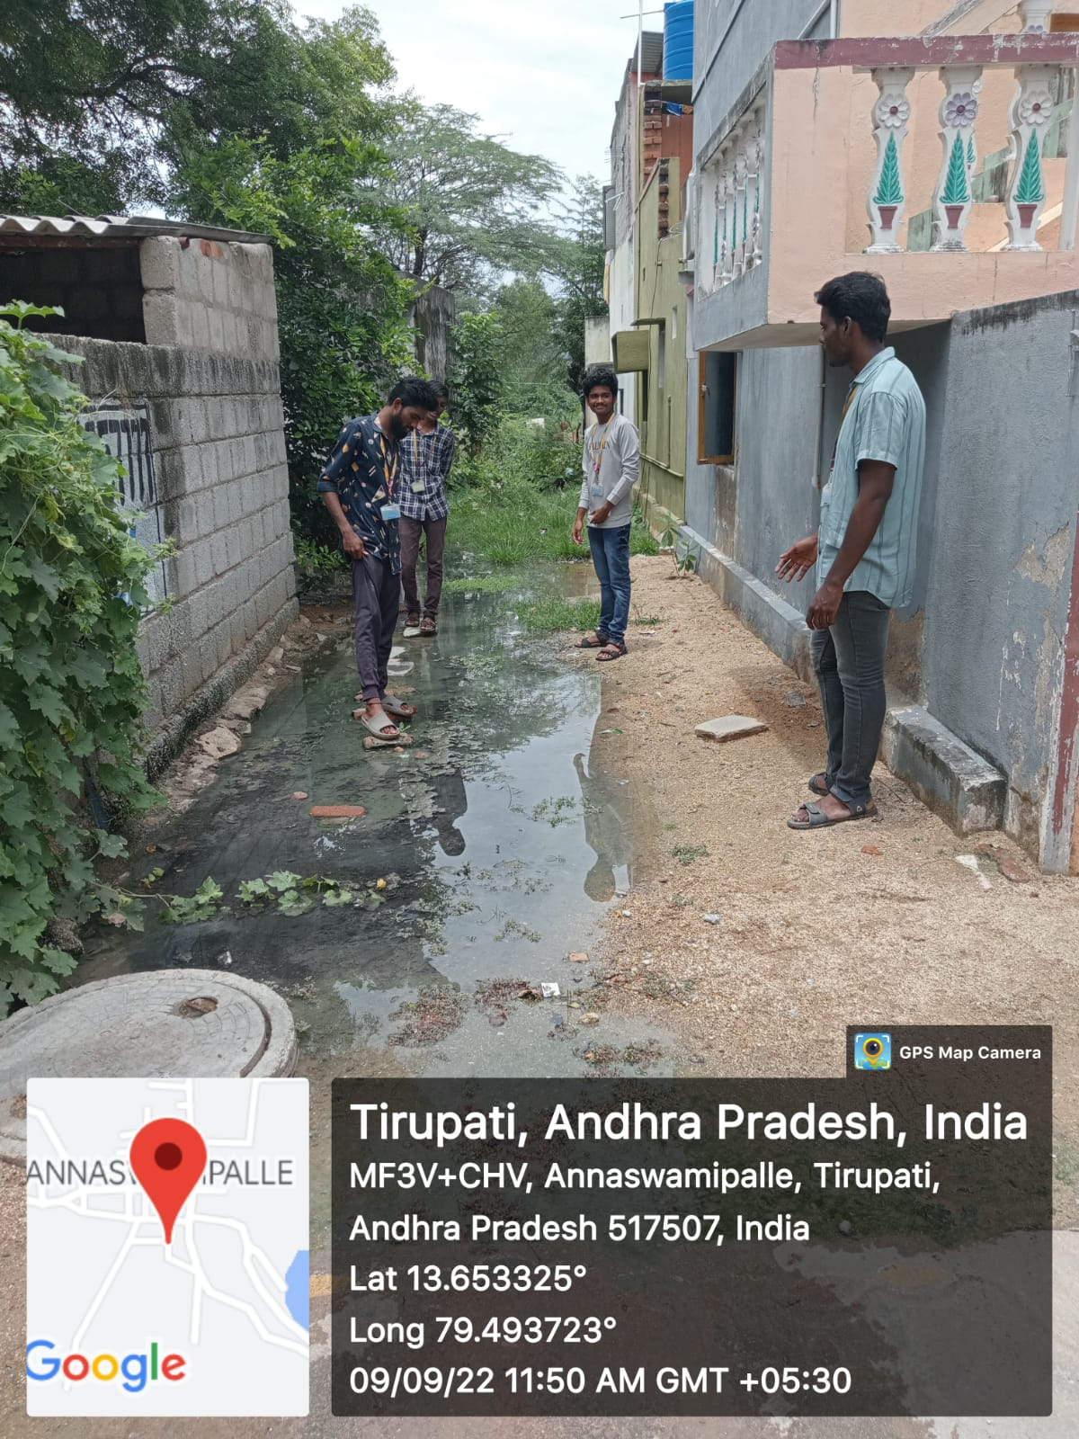

**GROUNDWATER EDUCATION ACTIVITIES**

* Teach the people in your community where their drinking water comes from, why it is vulnerable to contamination, and provide ideas for ways they can protect their water. Find out more about source water assessment and protection.
* Host a Test Your Well event for your community. This event allows well owners to have their water screened for common contaminants such as nitrates and offers opportunities to raise awareness on pollution prevention.
* Hold a “Mini-Groundwater Festival” for local residents. Teams could demonstrate groundwater concepts using activities in "Making Discoveries," The Groundwater Gazette, or by creating their own! Topics could include the water cycle, groundwater basics, local groundwater, and groundwater in other states and countries.
* Lead a groundwater education campaign. Activities could include: speaking to a local government board or council; creating and distributing educational posters, brochures, and newsletters throughout the community; being interviewed on a local TV station; and writing and recording a public service announcement for a local radio station.

We opted many techniques /management methods to protect crops from this heavy rainfall. Here are some methods we used in the fields to protect crops.

1. Unregulated extraction:Groundwater, regarded as a “common pool resource”, has historically witnessed little control over its extraction. Driven by a rising population, urbanisation and expansion of irrigation activities, groundwater extraction has been on the rise for several decades.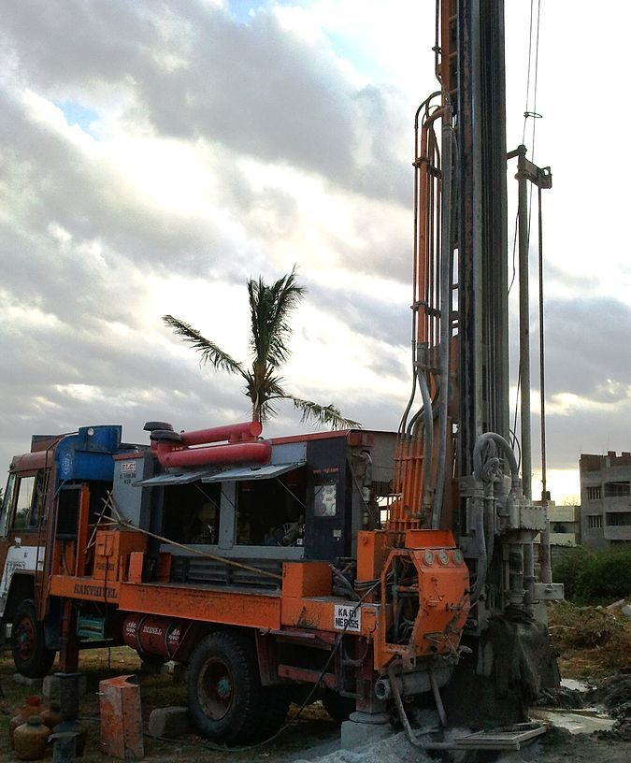
2. Excessive irrigation:Triggered by the Green Revolution, groundwater use has exploded in India since the 1970s. Availability of cheap electricity shifted farmers’ dependency from surface water to groundwater. [For instance, of the total irrigated area in Punjab, only 26.2% is irrigated by surface water](https://timesofindia.indiatimes.com/blogs/economic-policy/did-green-revolution-in-punjab-lead-to-groundwater-over-exploitation-revolution-due-to-msp/). This, despite five rivers flowing through the state.
3. Poor knowledge of ground water management systems: The mismatch in demand and supply at the local level represents a large part of the problem in India. The reasons behind this are multifaceted and may be less direct than say, a rising population or rampant urban development

Sewage effluent water is consistently used for the agricultural irrigation in rural and urban region farms. The spread of the potential infectious diseases is the major concern for farm workers and also for city inhabitant when they get exposed to these effluents. They also will affect those people consuming crops developed using effluent water irrigation system, particularly when the farm produce is consumed raw by people or otherwise, the farm yield is brought in that raw condition into the kitchen. Only way of preventing is by making adequate measures to disinfect the effluent. ***c***. Regrettably, no proper interest taken and awareness paid to curtail sewage irrigation long-term effects on principal groundwater.

**GROUNDWATER EDUCATION ACTIVITIES**

* Teach the people in your community where their drinking water comes from, why it is vulnerable to contamination, and provide ideas for ways they can protect their water. Find out more about source water assessment and protection.
* Host a Test Your Well event for your community. This event allows well owners to have their water screened for common contaminants such as nitrates and offers opportunities to raise awareness on pollution prevention.
* Hold a “Mini-Groundwater Festival” for local residents. Teams could demonstrate groundwater concepts using activities in "Making Discoveries," The Groundwater Gazette, or by creating their own! Topics could include the water cycle, groundwater basics, local groundwater, and groundwater in other states and countries.
* Lead a groundwater education campaign. Activities could include: speaking to a local government board or council; creating and distributing educational posters, brochures, and newsletters throughout the community; being interviewed on a local TV station; and writing and recording a public service announcement for a local radio station.

**WATER CONSERVATION ACTIVITIES**

* Design and install a rain garden for your school to capture rain water and reduce storm water pollution. Ask your local nursery for design help and the donation of plants.
* Check your home/school/business for leaky faucets, showerheads, and toilets. Calculate the amount of wasted water and have the leaks repaired.
* Research the availability and cost of water conservation equipment for the home/school/business. Replace appliances with environmentally friendly models when appropriate.

**POLLUTION PREVENTION AWARENESS ACTIVITIES**

* Prevent groundwater pollution from occurring in the first place by teaching people how to keep water safe for all of us!
* Stencil messages on storm drains to help prevent chemicals and oil from being dumped down them. These chemicals pollute both surface and groundwater and are dangerous to aquatic plants and animals.
* Design and distribute posters or fliers in the community which educate residents about the hazards of abandoned wells and how they should be properly filled.
* Share conservation messages that encourage the wise use of groundwater supplies. Examples could include performing a play or writing a comic book about water conservation.

**COMMUNITY WATER HISTORY AWARENESS ACTIVITIES**

* Investigate and share the history of your community’s successes and challenges in finding adequate and safe water supplies.
* Check local newspaper archives (at the newspaper’s office or at the library) to find stories from the past about your community’s water supply, including natural disasters which may have affected the supply.
* Interview senior residents about memories of your community finding safe water supplies through the years.
* Make a map showing your community’s water supply source. Display maps at schools, public libraries, and grocery stores.

#### How it’s effecting our day to day life!

Sewage effluent water is consistently used for the agricultural irrigation in rural and urban region farms. The spread of the potential infectious diseases is the major concern for farm workers and also for city inhabitantwhen they get exposed to these effluents. They also will affect those people consuming crops developed using effluent water irrigation system, particularly when the farm produce is consumed raw by people or otherwise, the farm yield is brought in that raw condition into the kitchen. Only way of preventing is by making adequate measures to disinfect the effluent. Moreover, the effluent water must meet all the conditions of usual irrigation water parameter needs such as trace elements, sodium adsorption ratio, salt content, and so on. Regrettably, no proper interest taken and awareness paid to curtail sewage irrigation long-term effects on principal groundwater. The irrigation water is mostly applied during the dry climatic conditions that evaporates quickly. Whereas, the non-biodegradable chemical concentration of the drained water and deep-percolated water goes down to join the groundwater, which may remain at a higher level than the effluent water itself. There are various chemicals included in such effluent water, comprising of various salts, potential pesticide residues, nitrates, and they are usually expected in the farming and irrigated farming. However, the chemicals in the sewage, such as pharmaceuticals, organic, synthetic compounds, by-products of disinfection, and pharmaceutical active endocrine disruptor, chemicals, Fumic acids are mainly known to be the main disinfection precursor by-products. They are formed as soon as the drainage water joins the drinking-water, which gets chlorinated subsequently. Therefore, the groundwater right under the sewage-irrigated regions finally can become completely unfit for human consumption and drinking. The is the main issue that is raising questions of its accountability and burden, when the sewage water irrigated. 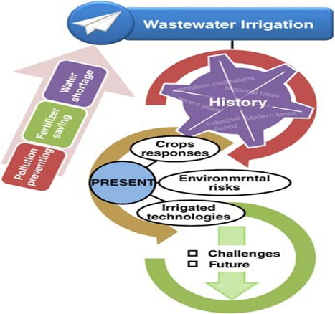

#### DISEASES ON CROPS

Due to an extensive growth of the population, most of the cities in the developing countries, turn into mega-cities and they require mega-clean water needs. Simultaneously, there are bound to be mega-sewage stream surge, creating mega-problems to plan, design and structure the entire city configuration. People living in countries having a high living standard, are likely to grow gradually, besides the United States, who is facing the basic immigration problem. When the population growth continues, there is an increase in demands to obtain more water, generating tremendous competition. The water resource management has to integrate all their activities, considering every aspect of the water problem, by applying a holistic approach to gain the best strategies to find solutions. For the knowledge sake, the of management water distributors must involve a demand management system to determine whether the problems related to better solutions of water shortage can be achieved economically by more efficient method of use, and effective conservation strategy, to get high economic returns, and other identical benefits, reuse, recycling, water pricing, and such measures (Oppel et al., 2004).

Integrating all the water management programs and systems can also include the management of water quality, efficient pollution control, public health, economics, ecological aspects, environmental aspects, sociocultural aspects, long-term water storage and banking, conjunctive application of groundwater, surface water, bringing involvement of people and community, with public conflict resolution, and flexible application of climatic changes (Naeem Khan, 2018). This also includes water supply changes with regional approaches, application of sustainability, the virtual water concept, and so on. This review paper tries to explore the reuse of water through irrigation, and how groundwater problems are caused by uses of sewage effluent water for irrigation purpose.

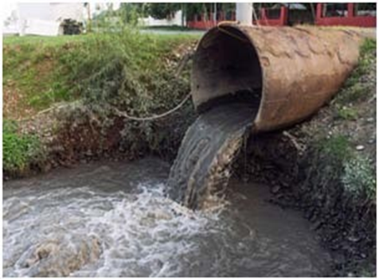

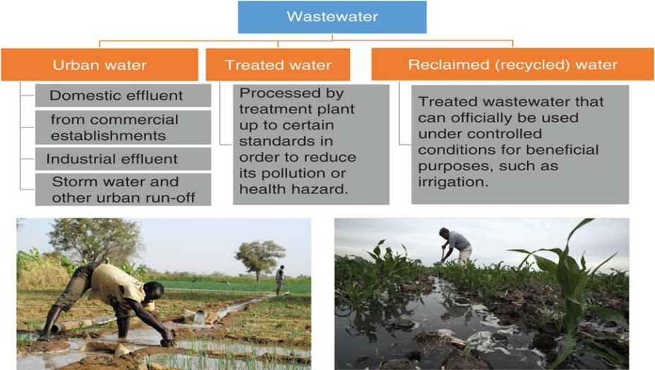

There are short-time benefits related to use of effluent water for irrigation, as they provide enough nutrients for development and growth of plant, for the soil improvement structure, and also for the increase in the yield of the crop (Jolly, Islam & Mustafa, 2012). The main effluent irrigation risk can be the likely propagation of infectious diseases in grazing animals near sewage-irrigated fields and also to people, who get exposed to the effluents, directly or indirectly. Lately, the authorities started investigating the long-term potential harm connected with the effluent water irrigation system, primarily the irreversible aspects of groundwater quality deterioration effects (Patil, Sawant & Deshmukh, 2012).

The raised anthropogenic contaminant concentration like heavy metals, organic chemicals, pharmaceuticals, effluent-based hormones, soil- generated organic pollutants, are well-known at effluent- irrigated groundwater sites. (Mahajan Saroj, 2014).

Due to various chemicals and salts in the irrigation source of water, they get leached out from the main root zone with much less water than the irrigation water applied, the salt content in the original water zone and it is leached out in the drainage water more than in that of irrigation water. The presence of chemicals in agricultural matters get percolated deeply in water arriving from the irrigated fields, and that degrades the water quality and characteristics of the primary groundwater (Satone et al., 2011).

# MUNICIPAL WASTEWATER TREATMENT REQUIREMENTS

If for irrigation, use of municipal wastewater is made, for road plantings, urban irrigation, agricultural irrigation, golf courses, parks, residential areas, sports fields, and so on, several chemicals from the wastewater can prove to be a real threat to harm the groundwater quality. This is an acute concern for dry climates, efficient irrigation, where the drainage water, chemical concentrations or its deep-percolation effect can increase in the wastewater also, depending on irrigation efficiency and rainfall. The concerned chemicals of include pesticide residues, various salts, mostly nitrogen as drainage water, nitrate, by-products of disinfection, active pharmaceutical chemicals, disinfection by- products, and many dissolved organic elements to form a new disinfection suite of by-products, no sooner the groundwater is sent up for chlorination or for drinking (Attila Bai, & Gabnai, 2021)

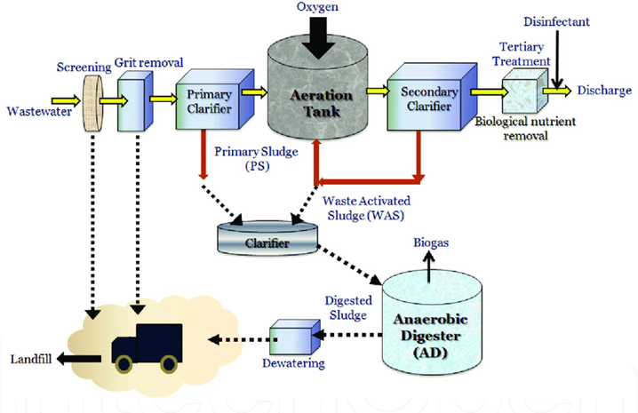

# GROUND WATER EFFECTS

Regrettably, the requirement of basic microorganism and chemicals for the purpose of municipal wastewater irrigation, do not include by- products of disinfection, pharmaceuticals, active chemicals, and various probable contaminants. The by- products of disinfection are already included involved in the wastewater and that enters the water plant treatment because of the drinking water chlorination process. The By-products are formed in this process of effluent treatment in the treatment plant wastewater, specifically when a long contract, large chlorine doses are used for the tertiary treatment. The ultraviolet irradiation of disinfection with filtration granular media can decrease disinfection levels of by-product in the region of tertiary effluent. Certain by-products of disinfection, like Haloacetic acids, Trihalomethanes were observed in biodegradable aquifers near the recovery and storage wells (Singer et al., 1993).

Also, by-products of disinfection are the major organic compounds of Halogenated products and their real identity is to-be-found and discovered, because they decide the fates of underground water and environment. The Trihalomethanes involves Bromodichloromethane and chloroform. The can create problems due to the harm to pregnant women. Concerning the dissolved salts, the by-products of nonvolatile disinfection and refractory concentration in the multi-layer drainage water percolation can also involve more than 500% higher than effluents used for the purpose of irrigation, even when the irrigation 80% efficiency is maintained. Due to its likely carcinogenicity, and toxicity, the by- product disinfection level in drinking water gets consistently analyzed, to find the optimum level of contaminants, to reduce that level in the future. The Environmental Protection U.S.

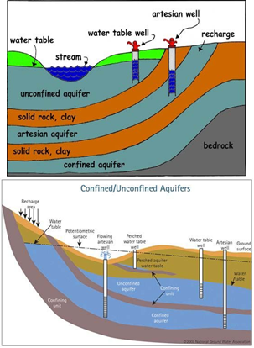

The high level of organic-carbon and nutrients in effluent water can also be expected to increase the Bioactivity and plant growth in the soil. The plant parts, decaying roots and other related biomass can also generate Fulvic and Humic acids as a secure end product. They are non-biodegradable elements, they are considered as by-product disinfection precursors in the groundwater, which is further chlorinated. Therefore, when effluent-irrigated groundwater from the lower areas is sent for chlorination for potable application and pumped for the purpose, a new disinfection byproduct suite can be generated.

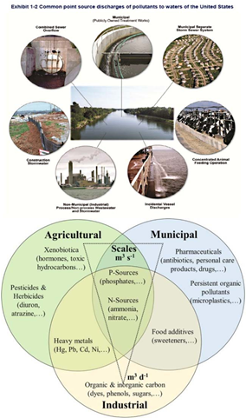

There is a major concern regarding the increase in active pharmaceutical chemicals that enters the waste discharge sewers including hospital, domestic, pharmaceutical, and industrial outlets of water (Menció, et al., 2016). The pharmaceutical effective chemicals in the wastewater can be treated and they normally are not adsorbed effectively in the soil particles. Hence, they can be intractable in the environment underground water sources.

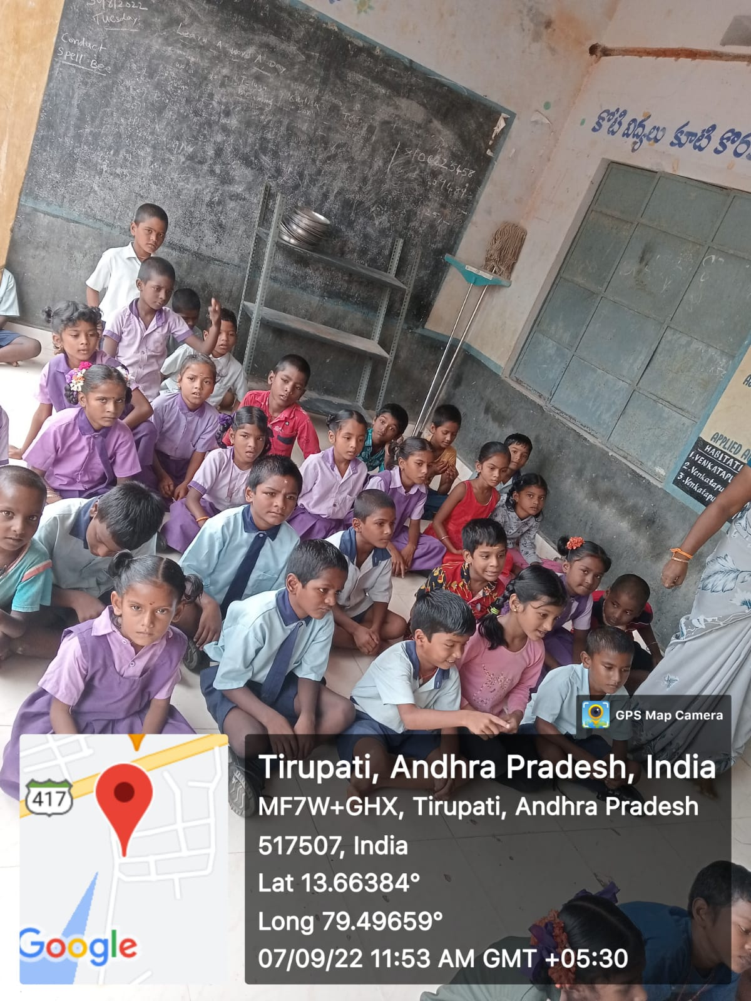

When joined the aquifer, it will cause the ground water level to increase. At that stage, the drainage water is likely to remain in upper aquifer level, at the top portion, according to the principles of vertical- stacking. Hence, the shallow wells obtain their level filled with water from the top portion of the aquifer, which will initially demonstrate the groundwater contamination evidence. The groundwater is pumped from the deep wells coming from the aquifer deeper portion or from basic confined aquifers and they will indicate the contamination level some other time (Subash Chandra Bose, et al., 2013).

#### Ground water contamination

Groundwater pollution due to pesticides is a worldwide problem. According to the USGS, at least 143 different pesticides and 21 transformation products have been found in ground water, including pesticides from every major chemical class. Over the past two decades, detections have been found in the ground water of more than 43 states. During one survey in India, 58% of drinking water samples drawn from various hand pumps and wells around Bhopal were contaminated with Organo Chlorine pesticides above the EPA standards. Once ground water is polluted with toxic chemicals, it may take many years for the contamination to dissipate or be cleaned up.

#### Soil contamination

A large number of transformation products (TPs) from a wide range of pesticides have been documented. Not many of all possible pesticide TPs have been monitored in soil, showing that there is a pressing need for more studies in this field. Persistency and movement of these pesticides and their TPs are determined by some parameters, such as water solubility, soil- sorption constant, the octanol/water partition coefficient and half-life in soil.

Pesticides and TPs could be grouped into:(a) Hydrophobic, persistent, and bioaccumulable pesticides that are strongly bound to soil. Pesticides that exhibit such behavior include the organochlorine DDT, endosulfan, endrin, heptachlor, lindane and their TPs. Most of them are now banned in agriculture but their residues are still present. (b) Polar pesticides are represented mainly by herbicides but they include also carbamates, fungicides and some organophosphorus insecticide TPs.

They can be moved from soil by runoff and leaching, thereby constituting a problem for the supply of drinking water to the population. The most researched pesticide TPs in soil are undoubtedly those from herbicides. Several metabolic pathways have been suggested, involving transformation through hydrolysis, methylation, and ring cleavage that produce several toxic phenolic compounds.

The pesticides and their TPs are retained by soils to different degrees, depending on the interactions between soil and pesticide properties. The most influential soil characteristic is the organic matter content. The larger the organic matter content, the greater the adsorption of pesticides and TPs.

The capacity of the soil to hold positively charged ions in an exchangeable form is important with paraquat and other pesticides that are positively charged. Strong mineral acid is required for extracting these chemicals, without any analytical improvement or study reported in recent years. Soil pH is also of some importance.

## Chapter 6: conclusion

The major aim of this review is to conduct an elaborate survey to assess the damage to groundwater and the environment caused due to use of sewage effluent water for irrigation purposes.

***Objectives***

1. To investigate the type and amount of sewage effluent reaching the irrigation applications;
2. To explore the inadequate waste water, its analysis, management procedures, and the related environmental and groundwater impact due to the problems caused by the use of sewage effluent for irrigation and the adverse health outcomes.
3. To explore the indirect and the indirect effects on groundwater caused by irrigation with sewage effluent water.
4. To explore whether these water pollution effects can be reversed.

WWT- Wastewater treatment has become a global problem. By applying any single technique or science, and due to a large scale of various contaminants in groundwater and Wastewater coming from wastewater, the conditions does not permit to purify the groundwater. Due to this in the industrialized nations, the water quality has touched an agonizing state (Shahid Malik, et al., 2020).

1. Waters at various locations contain a range of chemicals and pesticides, including an excessive intensity of NO 3, arsenic (As), boron (B), selenium (Se), along with metal traces like Lebron and Suarez. If such sewage municipal effluent is applied for the purpose of irrigation, without any proper treatment, the entire pollutant new spectrum gets included in the soil, that further joins groundwater, and thereon, joins the food chain of human beings and animals